**Experiment 6: Computing the center of Enceladus (Optional)**

1. **Objective**

(1) To master the method of extracting edges.

(2) To master the fitting-circle method.

(3) To be able to use a flexible combination of different methods to complete a complicated task.

1. **Experiment Content**

(1)The image file **enceladus.jpg** (given in the folder) shows one Saturnian satellite - Enceladus, which was took by Narrow Angle Camera in Cassini Spacecraft (see also [https://solarsystem.nasa.gov/missions/cassini/ mission/quick-facts/](https://solarsystem.nasa.gov/missions/cassini/%20mission/quick-facts/))

(2) Input the image enceladus.jpg, Extract the edge of Enceladus.

(3) Assume the shape of Enceladus is one perfect sphere. Compute the center position of Enceladus.

(4) If the pixel scale is 1.18km/pixel, obtain the real radii of Enceladus.

(5) Try to use different edge detection methods (for example, Prewitt, Sobel, Robert, and Canny) to get the center position and radii of Enceladus.

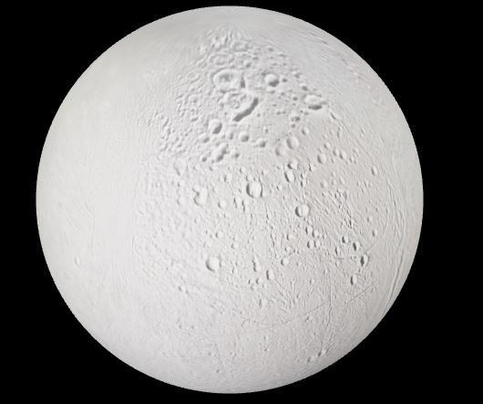

Figure 1. Enceladus.jpg

1. **Some Possible Matlab functions**

The functions that might be used in the experiment include **edge, bwboundaries, bwperim, imfilter** and so on. For more information, see the MATLAB HELP.

1. **Requirement of Experiment Report**

In your experiment report, you should

1. Describe the experiment procedure

2. Give the original image and resulted image in your experiment.

3. Compare your results from different methods.